Evan Baesler
08-28-2026

EE Design 1 Technical Report
PCB Design

Introduction
(Assigned Board: 8)

The primary objective of this introductory Junior Design project was to establish proficiency in Altium Designer and master the core fundamentals of printed circuit board (PCB) engineering.

Progressing from schematic capture to layout design, we successfully integrated a mix of generic and manufacturer-specific components into a production-ready system. Beyond basic tool navigation, this assignment provided critical insights into industry-standard design rules.

Ultimately, this foundational exercise bridged the gap between theoretical circuitry and the practical layout strategies required to deliver a manufacturable, high-efficiency physical board.

Methods
The methods section should include all background information needed for the design and steps used to create the results. Please cite any references used. Use subheadings as necessary. A figure of your assigned circuit to implement in Altium should be in this section.

Specific questions to answer in this section:
- Why are bypass capacitors important (i.e., what do they do)?
  - A bypass capacitor removes high-frequency noise from power and signals on the PCB. Similarly, a decoupling capacitor supplements the voltage on the board to any voltage sags and swells by storing charge.

- Where should bypass capacitors be placed on the board?
  - It is important for bypass capacitors to be placed nearest as possible to the IC pins as necessary to shorten return paths and lower the traces characteristic impedance.
- Explain the board outline and keep-out layer.
  - The board outline lets us specify geometric shape and dimensions for our board, so that we can have a set size or topology. The keep-out layer is where we tell Altium to not draw traces (for holes, antennae, etc.)

Results
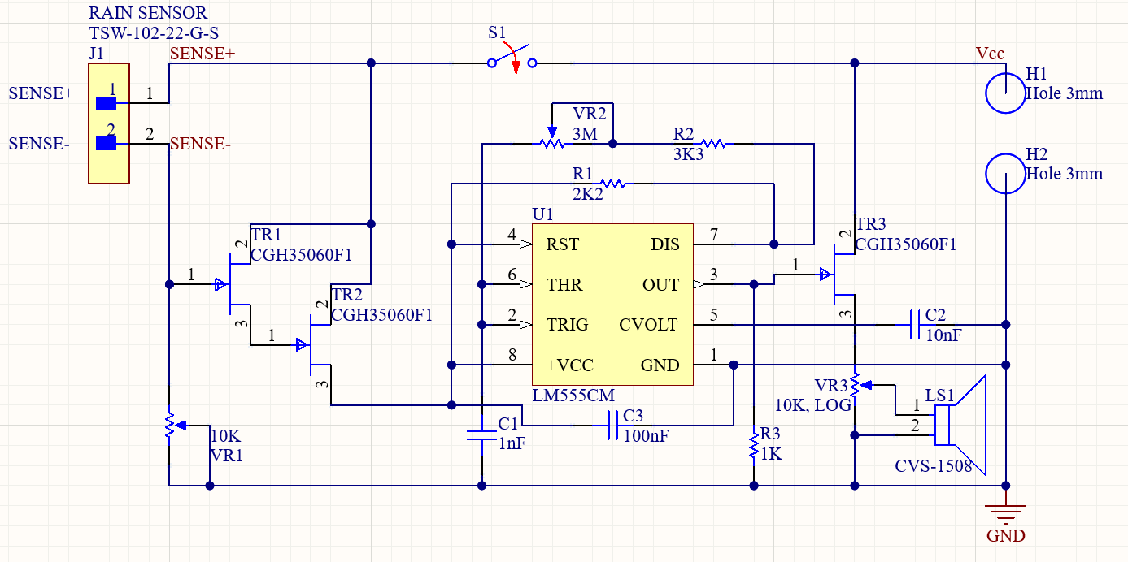
Figure 1: Rain Sensor Schematic, utilizing RC components, speakers, and ICs.
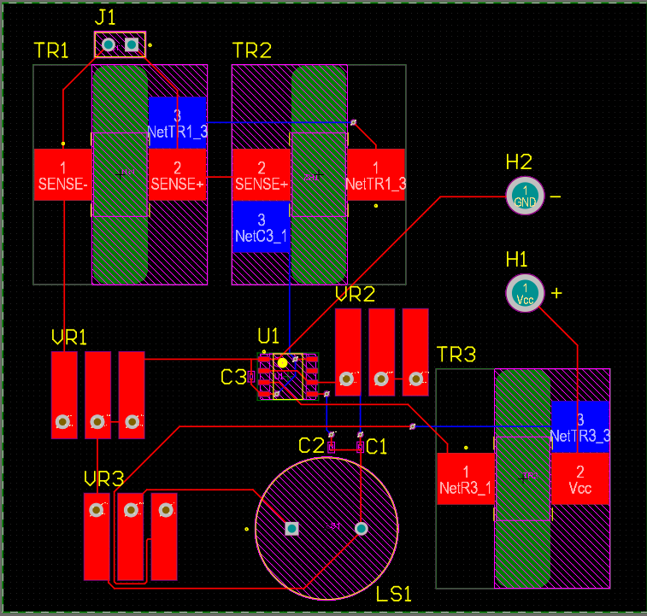
Figure 2: Rain Sensor PCB Layout on a two-layer board with vias.
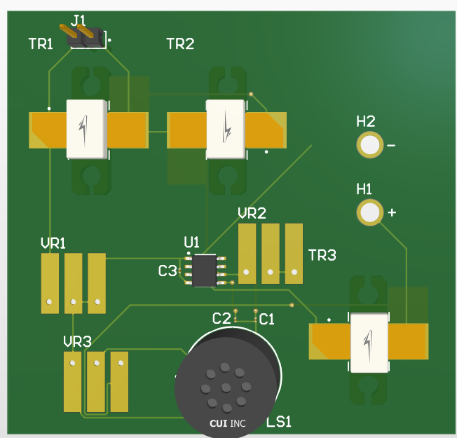
Figure 3: Front of PCB Layout (3D View)
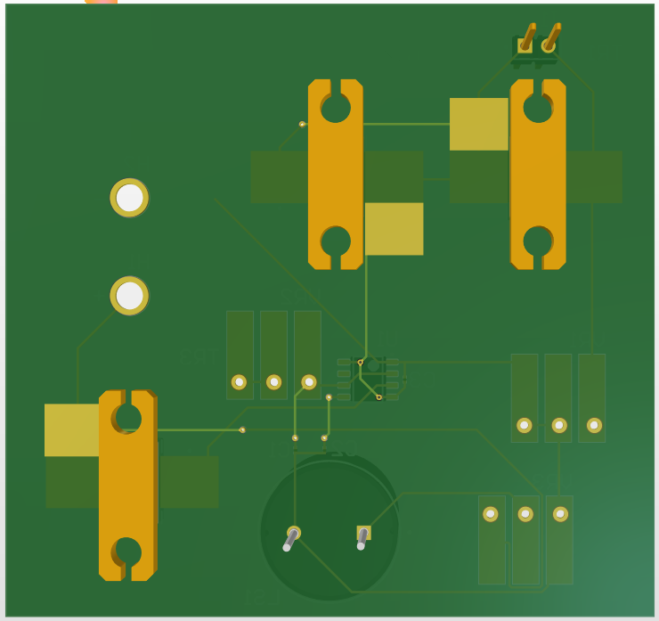
Figure 4: Back of PCB Layout (3D View)
Conclusion
This module reiterated the importance of understanding Altium for PCB design and the how to design higher-quality boards that would help us understand the industry standards. It showed up the importance of bypass and power integrity.

Diving into bypass capacitors showed us how they can decouple high frequency noise by sending it the ground plane whilst simultaneously blocking DC voltage (so that we can have our main power go straight to the board, and any noise will be ignored.) It also allowed us to learn more about how capacitors supplement charge and lead to the stabilization of the VCC on our board.

References
The Sierra Circuits Team. “What Is the Use of a Decoupling Capacitor?” Sierra Circuits, 30 Mar. 2021, https://www.protoexpress.com/blog/decoupling-capacitor-use/. Accessed 30 Aug. 2026.
Michael V. Stapleton’s videos on Altium Designer project setup and processes.
AI Usage: ChatGPT as necessary to supplement board understanding and best ways to organize the layout.

